

UNH SEDS

INFORMATION SHEET

Pg 2-5….……………………………...…..Slack

Pg 6……………………………….......OneDrive

Pg 7-8….………………………………...Github

Pg 9…………………………………….....Trello

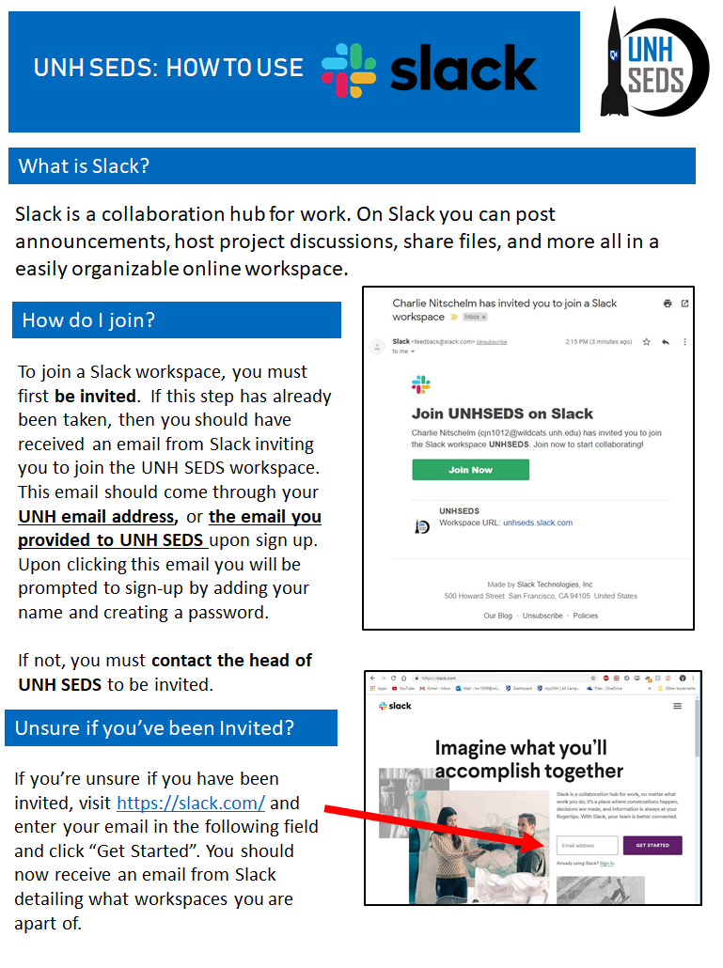

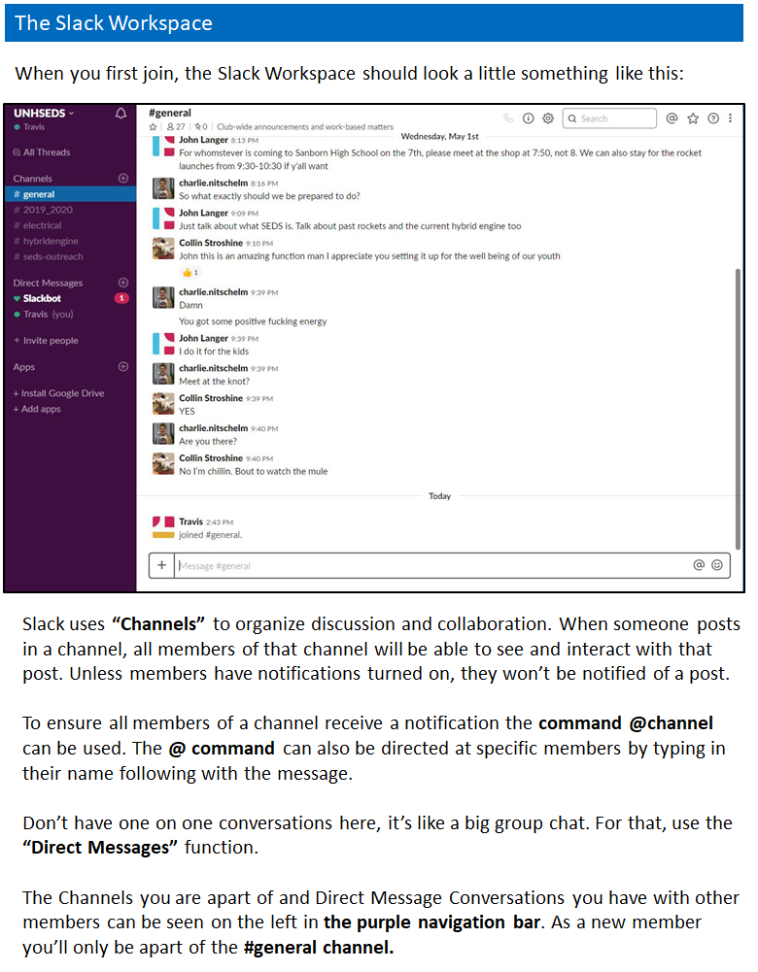

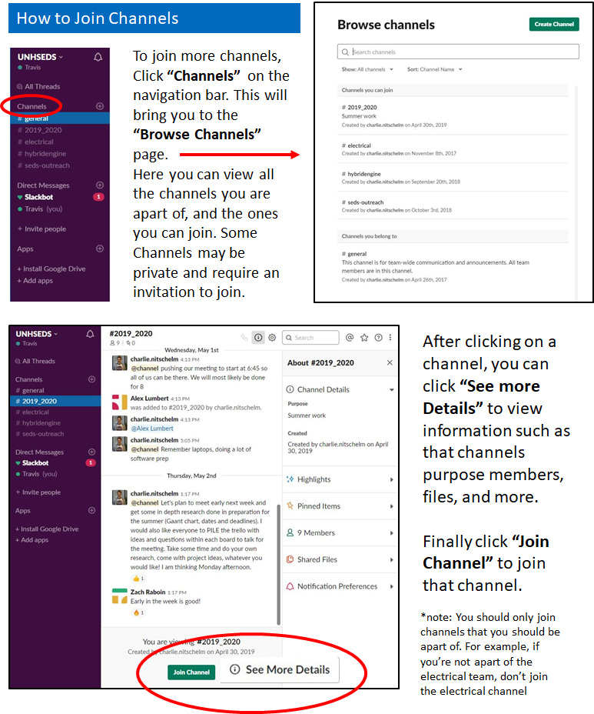

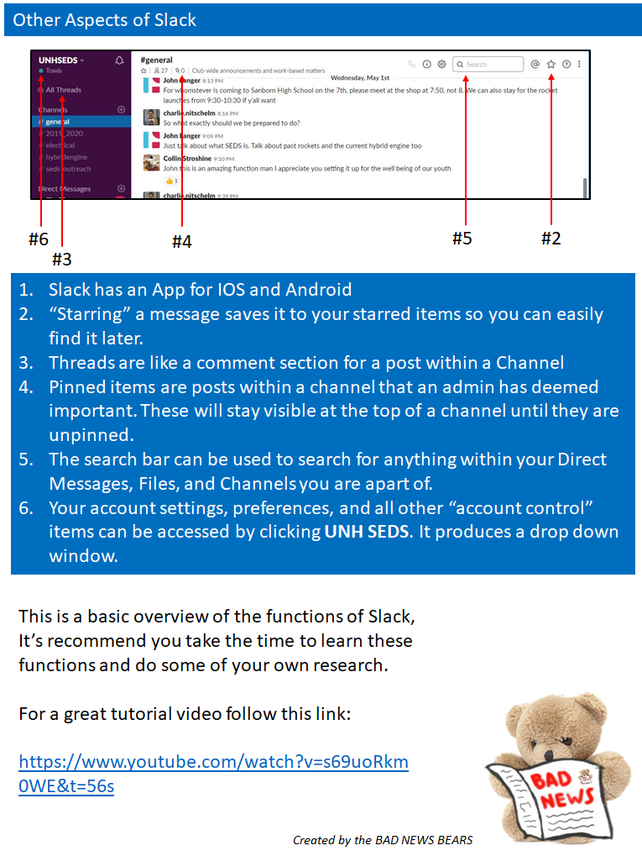

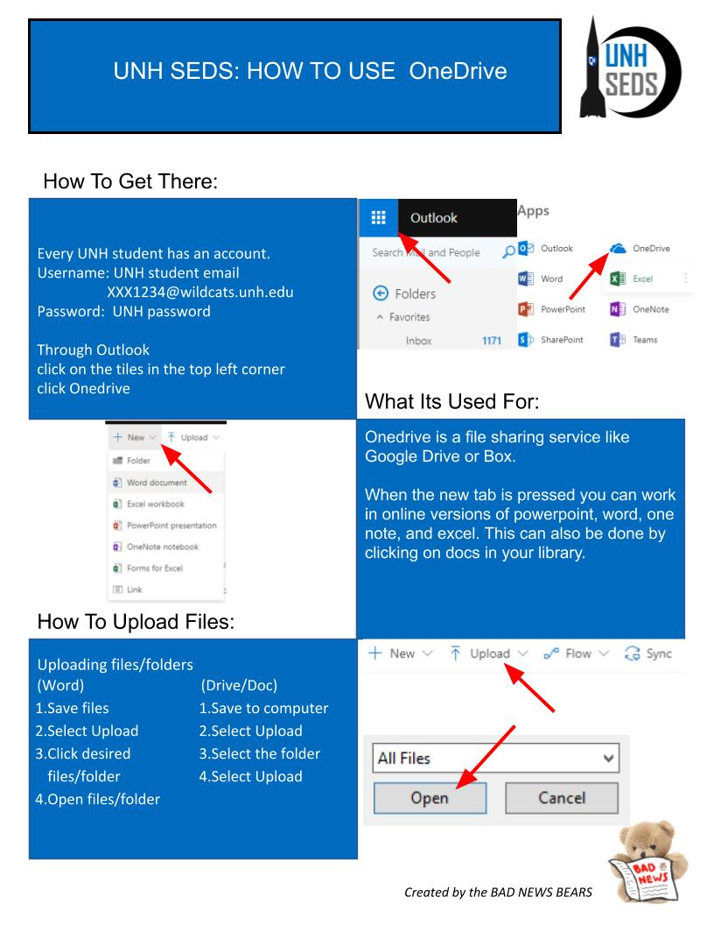**Github**

Is a code hosting platform for version control and collaboration. It lets you and others work together on projects from anywhere.

A **repository** is usually used to organize a single project. Repositories can contain folders and files, images, videos, spreadsheets, and data sets – anything your project needs.

**Branching** is the way to work on different versions of a repository at one time.

By default your repository has one branch named **master** which is considered to be the definitive branch. We use branches to experiment and make edits before committing them to master. When you create a branch off the master branch, you’re making a copy, or snapshot, of master as it was at that point in time.

**To Create a Branch:**

1. Go to your target repository

2. Click the drop down at the top of the file list that says **branch: master**

3. Type the branch name into the new branch text box

4. Select the blue **Create Branch** box

You have just made a branch of master.

On GitHub saved changes are called **commits.** Each commit has an associated **commit message**, which is a description explaining why a particular change was made.

**Opening a Pull Request:**

When you open a pull request, you’re proposing your changes and requesting that someone review and pull in your contribution and merge them into their branch. Pull requests show diffs, or differences, of the content from both branches. The changes, additions, and subtractions are shown in green and red.

1. Click the **Pull Request** tab, then click the green **New pull request**

2. In the **Example Comparisons** box select the branch you made to compare it with master

3. Look over your changes in the diffs on the compare page, make sure they’re what you want to submit

4. When you’re satisfied that these are the changes you want to submit, click the big green **Create Pull Request** button

5. Give your pull request a title and write a brief description of your changes

6. When you’re done with the message click **Create pull request**

**Merge your Pull Request:**

In this final step, it’s time to bring your changes together by merging your branch into the master branch

1. Click the green **Merge pull Request** button to merge the changes into master

2. Click **Confirm merge**

3. Go ahead and delete the branch, since its changes have been incorporated, with the **Delete branch** button in the purple box.

**Trello**

Is a collaboration tool that organizes your projects into boards, cards and lists. Also, trello can tell you what's being worked on, who's working on what, and where something is in a process.

Trello more like a white board, filled with lists of sticky notes, with each note as a task for you and your team. And, each of those sticky notes has documents, external resources or links and discussions with your team.

**Create Board**

1. When you login in to the Trello, click **“Create new board”** or [click the](http://help.trello.com/article/707-creating-a-new-board) **(+)** in the upper right corner, and select **“Create Board”**.

2. Name the board for whatever you are working on.

**Add Lists**

1. In your board page, Click **"Add a list"** to add list to your board. List names can be very direct such as “Documents,” “In Process,” and “Done”.

2. Add as many lists to your board as you need.

**Add Cards**

1. Click **“Add A Card”** in the first list to add card for each task that need to be completed.

2. Add more information on cards to let team know what needs to get done. The information can contain:

* Due Dates
* Links
* Discussions
* Documents
* Comments